**Worksheet – 2.4**

**Student Name:** Vivek Kumar  **UID:** 21BCS8129

**Branch:** BE-CSE (LEET) **Section/Group:** 809/A

**Semester:** 4th **Date of Performance:** 06/04/2022

**Subject Name:** Programming in Python Lab  **Subject Code:** 20CSP-259

**1. Aim/Overview of the practical:**

1. Write a Python program to replace last value of tuples in a list.
2. Write a Python program to remove an empty tuple(s) from a list of tuples.
3. Write a Python program calculate the product, multiplying all the numbers of a given tuple.
4. Write a Python program to convert a tuple of string values to a tuple of integer values.
5. Write a Python program to check if a specified element presents in a tuple of tuples.

**2. Task to be done/ Which logistics used:**

1. Write a Python program to replace last value of tuples in a list.
2. Write a Python program to remove an empty tuple(s) from a list of tuples.
3. Write a Python program calculate the product, multiplying all the numbers of a given tuple.
4. Write a Python program to convert a tuple of string values to a tuple of integer values.
5. Write a Python program to check if a specified element presents in a tuple of tuples.

**3. Steps for experiment/practical/Code:**

1. Write a Python program to replace last value of tuples in a list.

**Source Code:**

list_tup = []

item=[]

n = int(input("Enter number of Size of List: "))

for i in range(0, n):

print("Enter {}th tuple in list.".format(i+1))

tn = int(input('Enter the Tuple Size: '))

for j in range(0,tn):

ele = int(input())

item.append(ele)

list_tup.append(tuple(item))

item=[]

print('Given List of Tuples are: ',list_tup)

replacement=int(input('Enter the number for last tuple item: '))

print('Last item Replaced list of Tuples are: ',[t[:-1] + (replacement,) for t in list_tup])

1. Write a Python program to remove an empty tuple(s) from a list of tuples.

**Source Code:**

def removet(li):

li=[ num for num in li if num]

return li

*# Static list of tuples*

li=[ (), ('Studytonight', '1', '2'), (), ('3', '4', '5', '6') ]

print('Given list of Tuples are: ',li)

print('After Removing Empty Tuples: ',removet(li))

1. Write a Python program calculate the product, multiplying all the numbers of a given tuple.

**Source Code:**

def mutiple_tuple(nums):

temp = list(nums)

product = 1

for x in temp:

product *= x

return product

item=[]

n = int(input("Enter number of elements : "))

for i in range(0, n):

print("Enter {}th elements of Tuples: ".format(i))

ele = int(input())

item.append(ele)

nums=tuple(item)

print ("Original Tuple: ")

print(nums)

print("Product - multiplying all the numbers of the given tuple:",mutiple_tuple(nums))

1. Write a Python program to convert a tuple of string values to a tuple of integer values.

**Source Code:**

def tuple_int_converter(tuple_str):

int_item=[]

for x in tuple_str:

int_item.append(int(x))

result=tuple(int_item)

return result

item=[]

n = int(input("Enter number of elements : "))

for i in range(0, n):

print("Enter {}th elements of Tuples: ".format(i))

ele = str(input())

item.append(ele)

tuple_str=tuple(item)

print("\nOriginal tuple with String values:")

print(tuple_str)

print("\nNew tuple with integer values:")

print(tuple_int_converter(tuple_str))

1. Write a Python program to check if a specified element presents in a tuple of tuples.

**Source Code:**

*# Static tuples*

my_tuple = (('Mon',10),('Tue',8),('Wed',8),('Thu',5))

print("Given tuple: ",my_tuple)

inputype=input('Do you want to search string (y/n): ')

if inputype=='y':

key=input('Enter the Element want to search: ')

else:

key=int(input('Enter the Element want to search: '))

if any(key in i for i in my_tuple):

print("present")

else :

print("Not present")

**4. Result/Output/Writing Summary:**

1. Write a Python program to replace last value of tuples in a list.

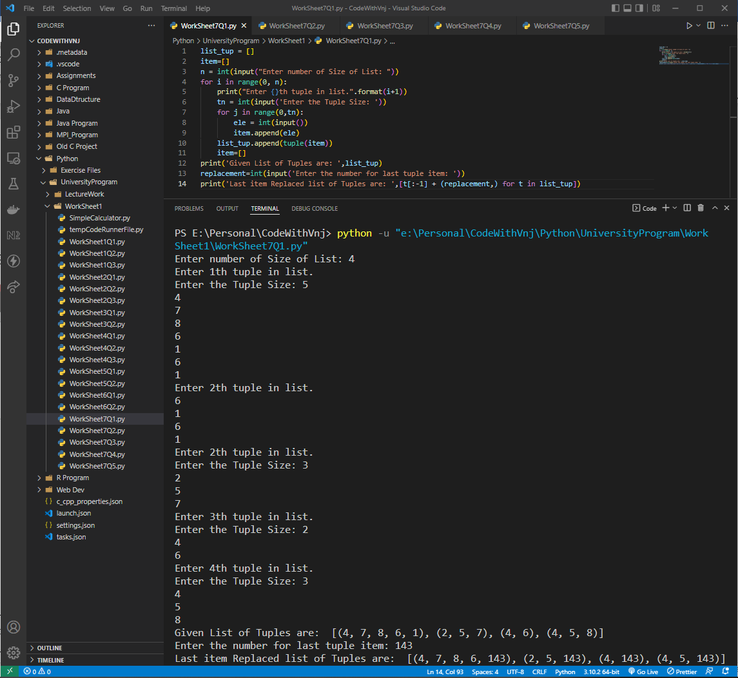

1. Write a Python program to remove an empty tuple(s) from a list of tuples.

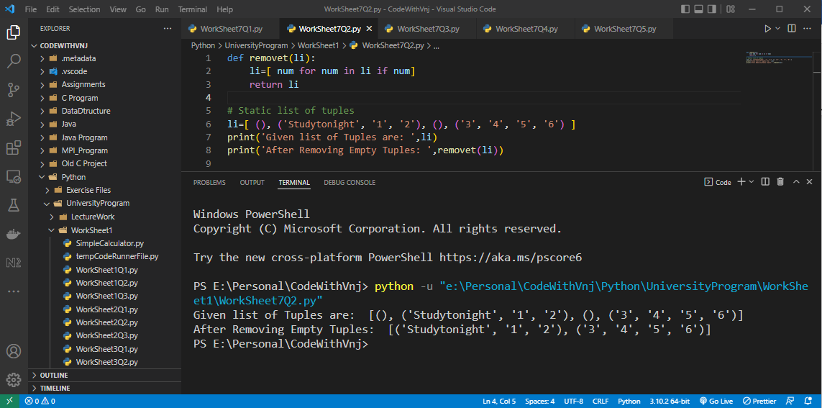

1. Write a Python program calculate the product, multiplying all the numbers of a given tuple.

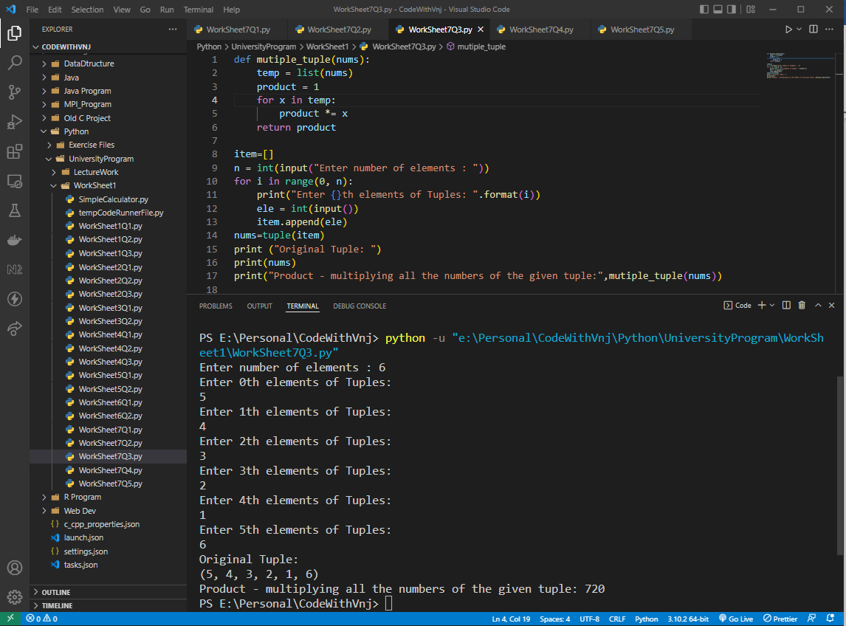

1. Write a Python program to convert a tuple of string values to a tuple of integer values.

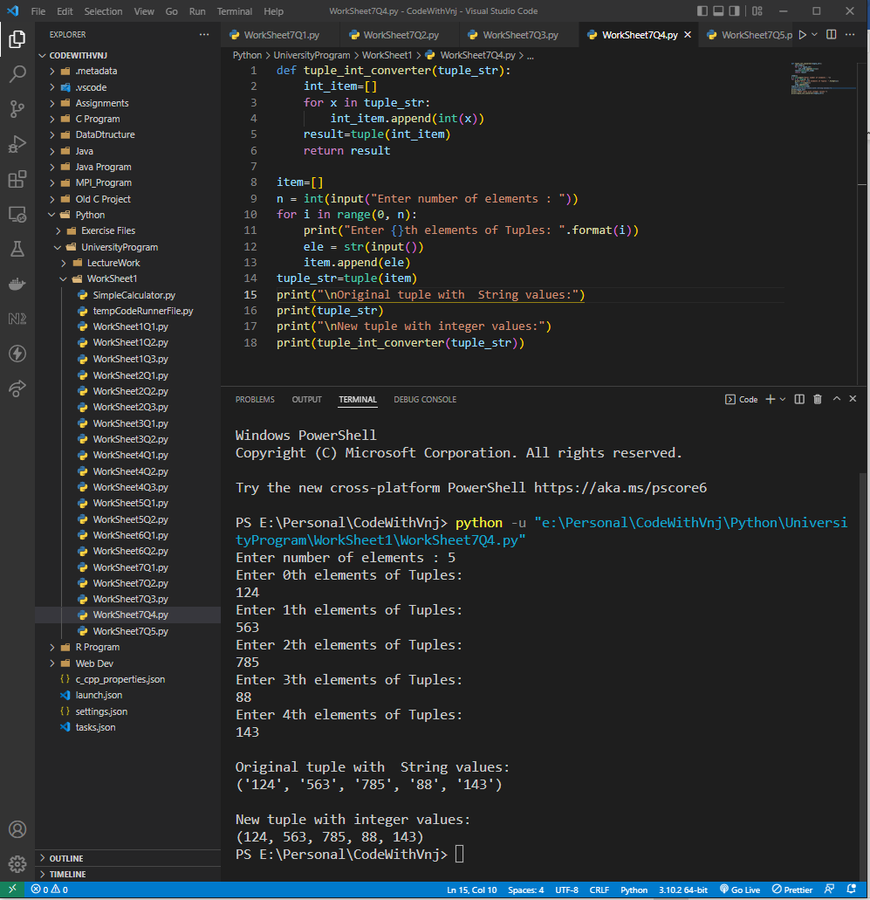

1. Write a Python program to check if a specified element presents in a tuple of tuples.

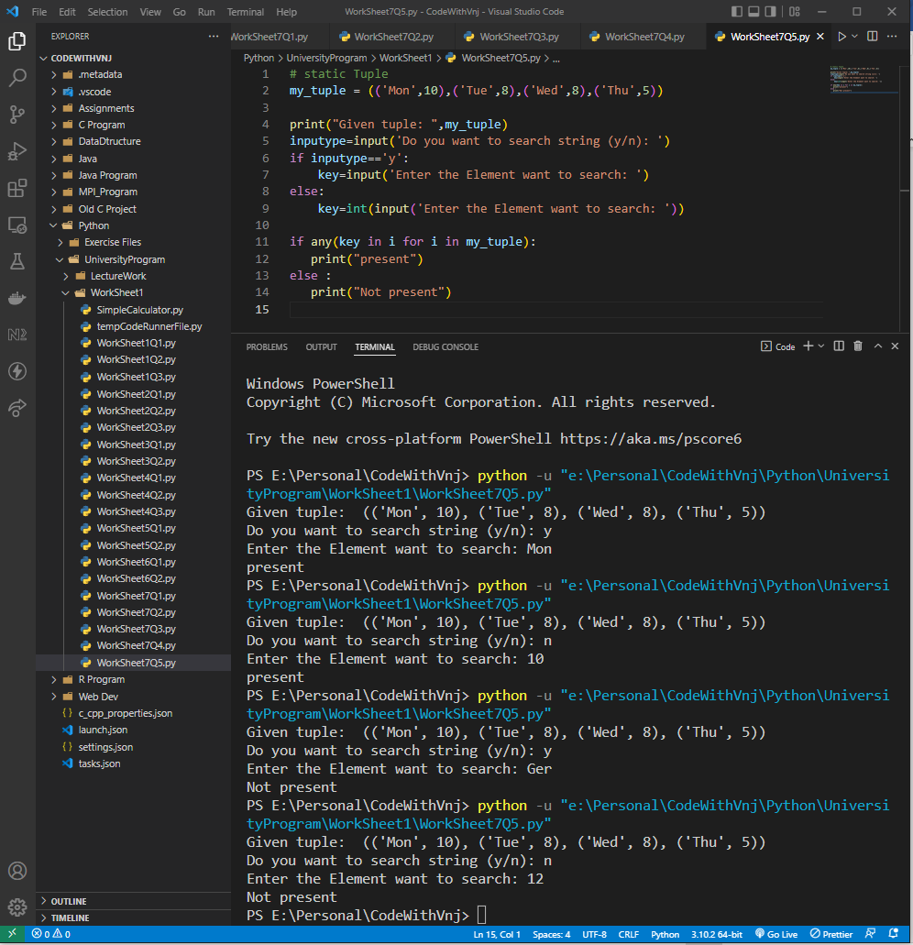

**Learning outcomes (What I have learnt):**

**1.** I have learnt, how to take List as well as Tuple Input from User.

**2.** Learnt to manipulate tuple with their last element.

**3.** Learnt to tuple Manipulation.

**Evaluation Grid (To be created as per the SOP and Assessment guidelines by the faculty):**

|  |  |  |  |
| --- | --- | --- | --- |
| Sr. No. | Parameters | Marks Obtained | Maximum Marks |
| 1. |  |  |  |
| 2. |  |  |  |
| 3. |  |  |  |
| 4 |  |  |  |